Helpers prepared and ready to lead the Easter Journey and the wooden cross in the sanctuary with some of the children’s messages pinned to it
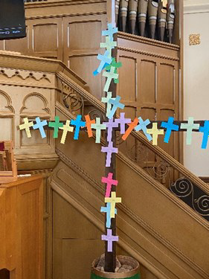
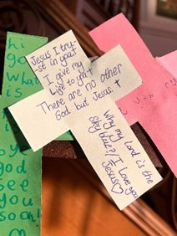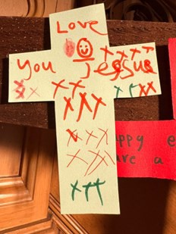
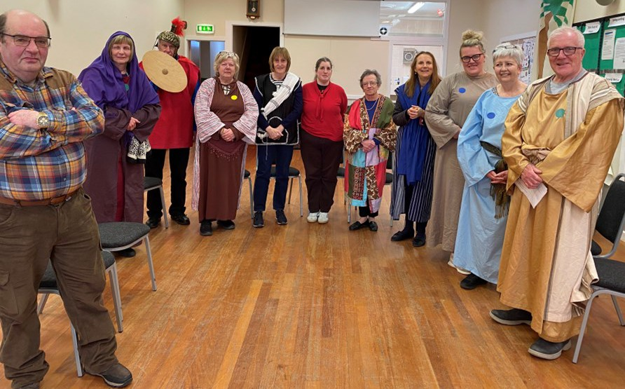


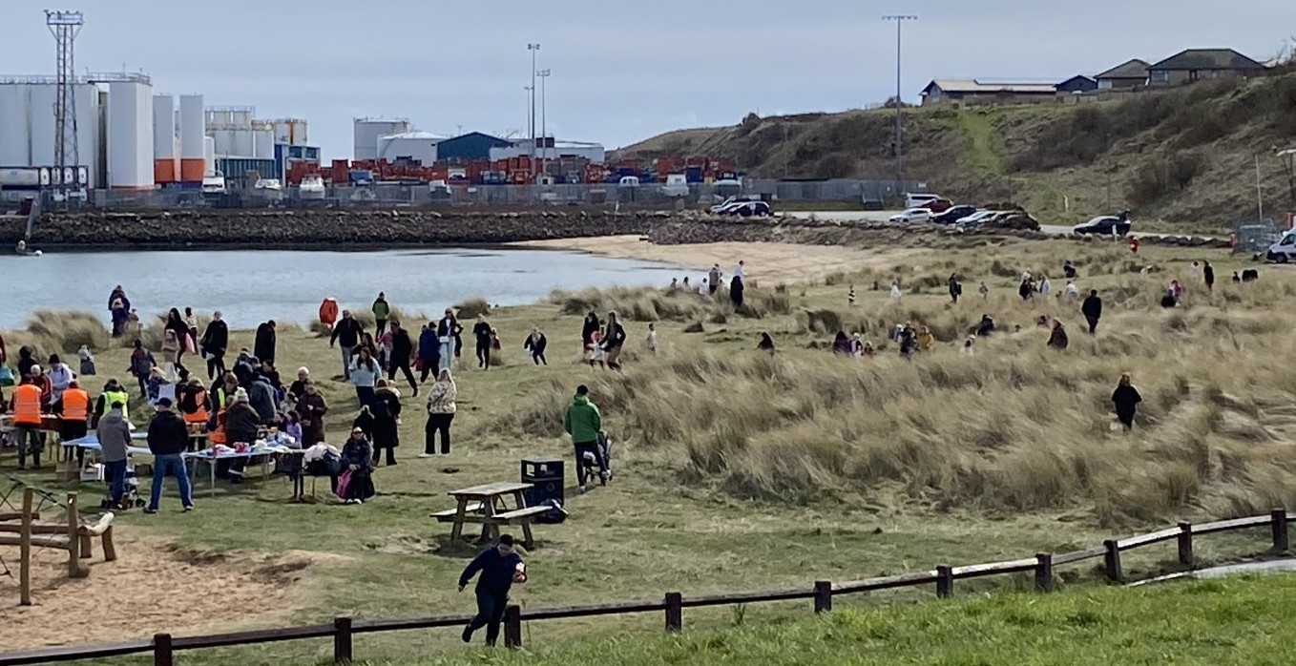
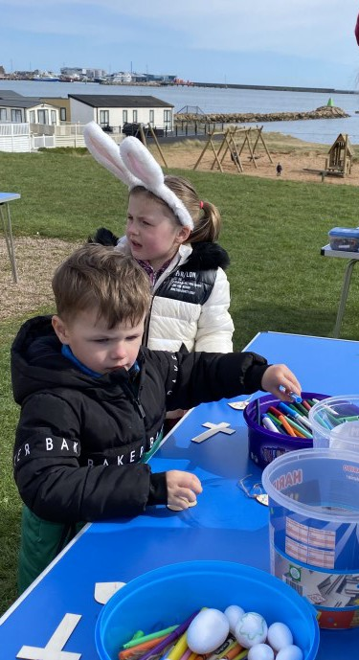
A busy day at the Lido with the children out hunt- ing for the hidden eggs. When they had found five eggs, they had to go to the table and collect one of the prizes.

Trying out one of the crafts on offer

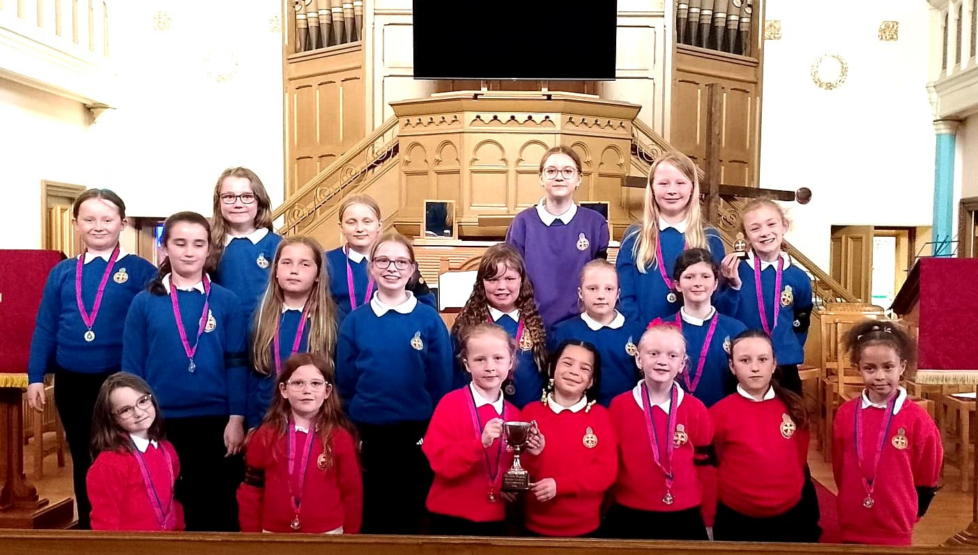
THE GIRLS BRIGADE

The girls pictured with their medals at the recent Girls’ Brigade Open evening in the hall, attended by family and friends, when Explorers, Juniors and Brigaders demonstrated some of the activities they had taken part in over the year as well as letting us know some of what they have learnt and what they have achieved.
Also pictured are Megan Mckay and Anna Pizzuto-Pomaco who have completed their Gold Leadership training. Well done ladies!

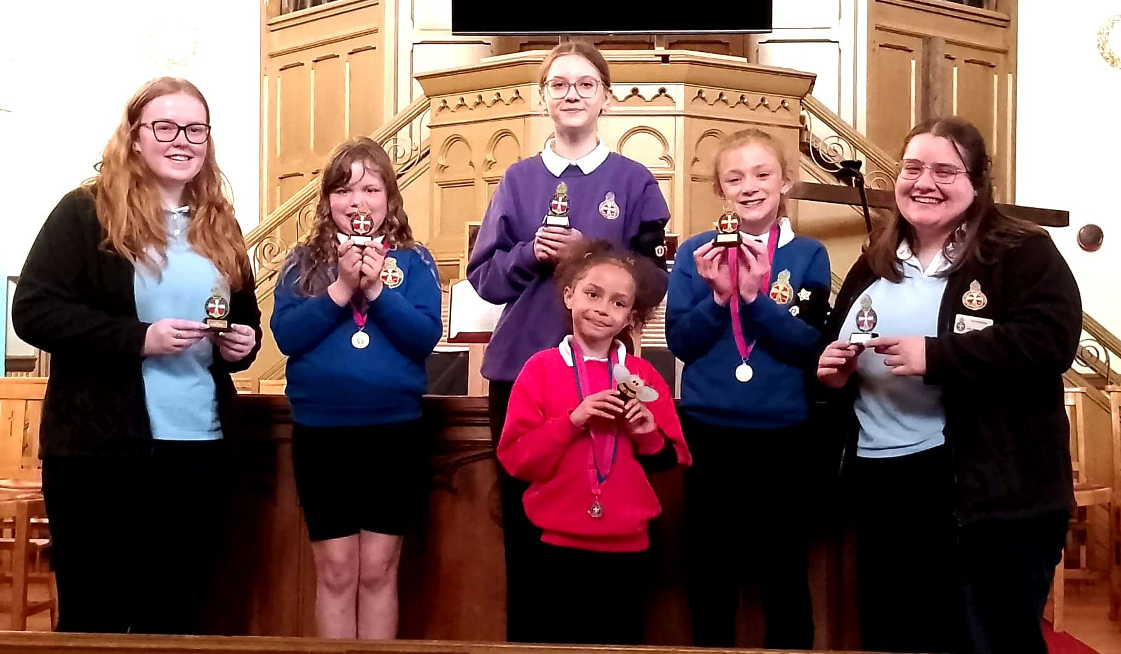
The whole company singing “The bees go buzzing.”
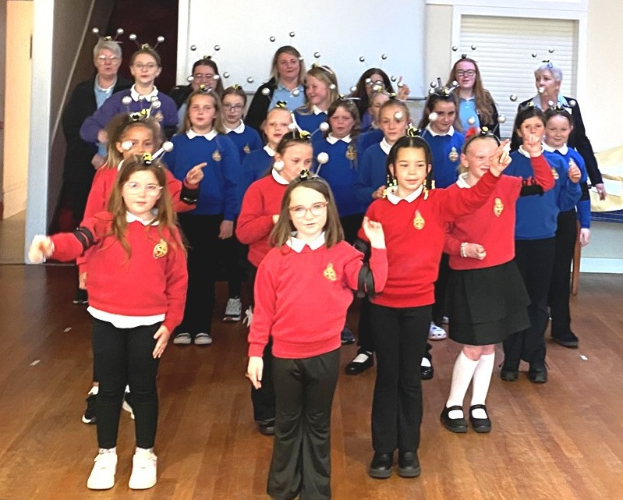





jpizzuto-pomaco@churchofscotland.org.uk
DATE | DOOR ROTA | AFTER CHURCH | FLOWER | CHILDREN’S | COUNTING
DATE | DOOR ROTA | TEA ROTA | ROTA | CHURCH | ROTA
June
7th | J. Copland, F. McKenzie | B. Stephen, A. Grant,  S. Robertson | I Stewart | Elsie and Edna | J. Copland,  R. Mackenzie
14th | R. Mackenzie, B Wood | I. Stewart, S. Marshall | Anne Collin | Olga and Jennifer | A. Grant,  N. Grant
21st | M. Simpson, M. Glennie | E. Johnstone, E. Munro  A. Milne | K Hay | Sylvia and Aileen | M. Glennie,  M Simpson
28th | J. Cowie, B. Stephen | R. Murray, S. Elder,  A. Wilson | Ann Grant | Ann and Margaret
July
5th | M. Simpson, M. Glennie | S. Scoular, A. Turner | Ruth Murray | Pat and Mary | M. Glennie, M Simpson
12th | R. Mackenzie, B Wood | M. Philip, C. McGee | F. Mackenzie | Ann and Brenda | A. Johnstone,  E. Smith
19th | J. Cowie, B. Stephen | A. Hastie, O. Wise |  | Elsie and Edna | J. Copland,  R. Mackenzie
26th | A. Grant, S. Scoular | M. Gray, O. Hamilton | E. Munro | Sylvia and Aileen | A. Grant,  N. Grant
Aug
2nd | J. Copland, F. McKenzie | B. Stephen, A. Grant,  S. Robertson | Elsie | Ann and Margaret | S. Elder,  J. Copland
9th | M. Simpson, M. Glennie | I. Stewart, S. Marshall |  | Pat and Mary | M. Glennie,
16th | R. Mackenzie, B Wood | E. Johnstone, E. Munro  A. Milne |  | Olga and Ann | A. Johnstone,  E. Smith
23rd | J. Cowie, B. Stephen | R. Murray, S. Elder,  A. Wilson |  | Sylvia and Aileen | J. Copland,  R. Mackenzie
30th | A. Grant, S. Scoular | S. Scoular, A. Turner |  | Elsie and Edna | A. Grant,  N. Grant
Sep
6th | J. Copland, F. McKenzie | M. Philip, C. McGee | Elsa | Amy and Olga | S. Elder,  J. Copland
13th | M. Simpson, M. Glennie | A. Hastie, O. Wise | F. Mackenzie | Ann and Brenda | M. Glennie, M Simpson
20th | R. Mackenzie, B Wood | M. Gray, O. Hamilton | Rosie | Elsie and Edna | A. Johnstone,  E. Smith
27th | J. Cowie, B. Stephen | B. Stephen, A. Grant,  S. Robertson | June | Ann and Margaret | J. Copland,  R. Mackenzie

 | CHURCH OFFICE BEARERS
MINISTER | Rev Dr Julia Pizzuto-Pomaco, 15 Inchmore AB42 3BG 01779 | 471714
SESSION CLERK | Miss Ruth Mackenzie 56 Watson Crescent, Peterhead | 480680
TREASURER | Mrs T Gammack 21 Wallace Crescent, Peterhead | 481551
GIFT AID/FREE WILL | Mr J Copland 34A King Street, Peterhead | 479644
OFFERING CONVENER ROLL KEEPER | Mrs Brenda Stephen 29 Buchanness Dr. Boddam | 473370
GIRLS BRIGADE – Captain | Mrs Sylvia Scoular Mo Dhachaidh, Cruden Bay | 812527
THE GUILD - Convener  SENIOR LADIES | Mrs Brenda Stephen 29 Buchanness Dr, Boddam,  Peterhead, AB42 3AT | 473370
FELLOWSHIP – President | Mrs Sheila Marshall 4 Buchan Terrace, Peterhead | 471378
ORGANIST | Mr Adam Horton 14 Captain Gray Pl, Peterhead | 473750

MAGAZINE TEAM Mrs Brenda Stephen, Mrs Noreen Wilson, Mrs Ann Grant
brendastephen03@gmail.com Scottish Charity Number: SCO 09990

Mission Statement

We seek through faith in our Lord Jesus Christ and obedience to his commands to promote the worship, life and pastoral care of the parish; to dispense the sacraments; to be open to His Spirit so that we may discern God’s will for the community of Peterhead and for the changing world and be empowered through prayer to carry it out.

DEATHS


Miss Anna Florence 24 Clerkhill Road, Peterhead
FLOWER ROTA
The Flower List is available to allow people to donate either money or flowers on a particular Sunday in the year. These flowers are then delivered to those who are ill, those who are housebound, those who maybe think they are forgotten about because increasing frailty stops them coming each week, those who just need to know someone cares. You can either give money and some one else will arrange flowers for you or
you can buy and arrange them yourself. For further information, please speak to June Cowie.

Mrs Elizabeth Bowie Grange Park Care Home, Peterhead
(formerly 3A Davidson Drive, Mintlaw)

Mr Douglas McRobbie 9 Abercorn Cres. Edinburgh
(formerly 29B Kirk Street, Peterhead) Mrs Judith Mackie 19 Whitegates, Peterhead
CHILDREN’S CHURCH .
Thank you to everyone for volunteering to be on the Children’s Church rota. You are much appreciated. If there is a week you cannot manage, please feel free to swap with someone else.
Mrs Morag Antczak Kirkburn Court, Peterhead
(formerly 31 Petergrange Rd Peterhead)

In his resurrection is our hope!

2

If you are unable to come on any particular Sunday for any of the rotas, please try and swap with someone. Thank you.
15

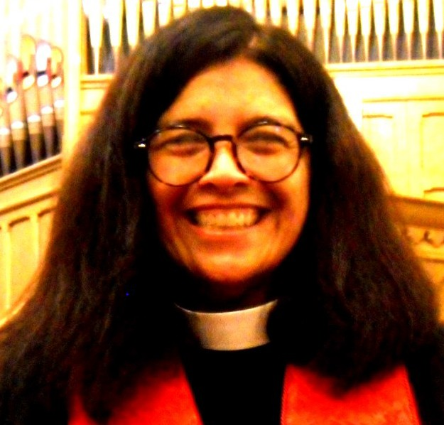
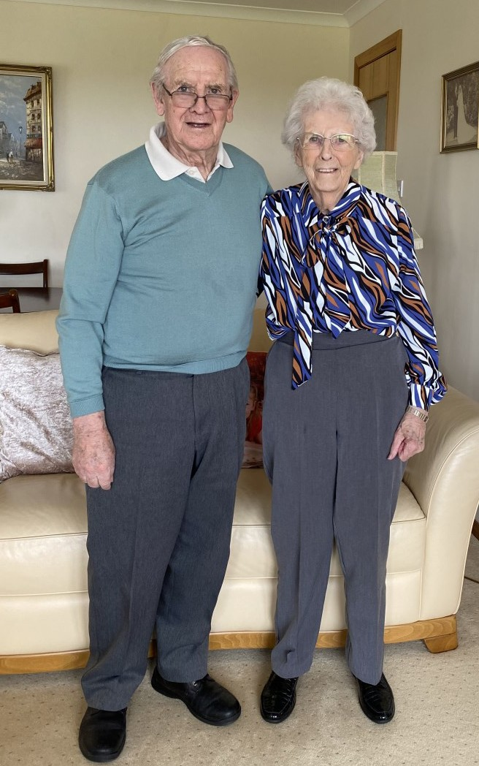
Be still
CONGRATULATIONS
to Nat Davidson who celebrated his 90th birthday on 27th May. He was an elder for fifty years, twenty of them as treasurer of the Old Parish Church. In the same week, he and his wife Ethel, celebrated their 66th wedding anniversary. They were married in the West Church as it was called then. Ethel also had 40 years in the Young Wives and Guild in the Old Parish Church and the Church has always been part of their lives. Of course they are now members of the New Parish Church

We wish them many more happy years together
Message from OUR MINISTER — REV DR JULIA PIZZUTO-POMACO
We have had such an amazing start to Spring with loads going on including baptisms, Easter Egg hunts, a youth Sunday and so much more! I am grateful for everyone who has participated in making our church a vibrant centre of the gospel in our community. I am overwhelmed by the work of the Holy Spirit in our midst bringing new youth, families and older folks to join us in our worshipping community. I have not seen the outpouring of God in this way ever in all of pastoral ministry in the last 25 years. I pray we would continue to hunger and thirst to see
more of God in all ways and that we would continue to do our part to rise up and share his love in our broken and chaotic world.
Yet today I write this sitting at home and not being able to participate in some things I would have liked to do. A few days ago an ordinary virus hit me and has had me down and in bed, missing lots of Lydia’s dance shows this weekend and failing to be able to set up the start of our bible study again for next week. I dislike staying at home. I have always been like that. I remember my mum once telling me when I was just a tot, I used to look out the picture window at our home and ask if I could go with my older brothers to school and she claimed my first sentence was ‘I want to go out.’.
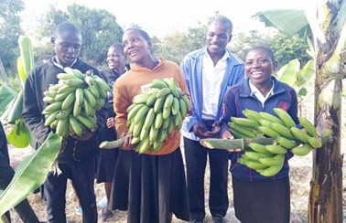As much as I like people and adventures there are times when I need to stay still. After Joe died I had to listen to advice and not return to ministry right away. My emotions were raw and there was so much new to figure out. I am thankful I listened to sage advice givers in my life because it has made all the difference to my ministry now.
WORK PARTY—NEWS FROM EKWENDENI
Container 16 has arrived safely and has been unloaded. Everyone stood in silence in memory of Alan Laverock. Willan Kalinda Numwenda sends his sincere thanks for all the support he has had from Scotland since the loss of Alan who was his friend and mentor.
A cycling club has been established in Malawi. The organisers send heartfelt thanks to the people in Scotland who sent them jerseys.
Feeding the Future. Leaders are progressing with the school meals. They find the children
will come to school because they get a meal.
Bright Futures Nursery and Secondary Schools are empowering young minds in Malawi. Education is the way forward in Malawi
Coffee is a source of income. To this end 5,000 plants have been sown in January/February. A bumper crop of tomatoes have been harvested this year. These will be sold for more income.
In managing land usage bananas are interplanted with maize at the three farms - Bula, Eden and Laverock. The maize did
really well in all the farms.
The surplus from input costs will go towards the School Feeding Programme.
The
4th
lot of chickens are
growing well. This is still small scale but we trust in God that it will expand. The ultimate goal is to see Banana Box Plus
being independent financially and be sustainable in its work.
.A message has come in from Willam to say thank you to the Work Party and all who support us.
Banana Box Trust container 17 is packed and ready to leave Dundee. This is the end of an era, but not the end of the partnership between Scotland and Malawi. New premises have been found in Bathgate and we will support them.
This week has been frustrating because I had to slow down. There was a school assembly on Friday but thankfully someone stepped in. I had to have folks help me at Lydia’s dance shows this weekend but many people stepped in and kept her going in a positive direction. I am having to consider that I might not be able to take on my upcoming busy week and will have to cut a few things…I don’t like that either. But we must listen when God is calling us to be still.
Psalm 46 is one of my favourite Psalms and it has a lot to say about trusting God and knowing that he is in control. Two of the verses I find meaningful in it are verses 10 and 11:
He says, “Be still, and know that I am God; I will be exalted among the nations, I will be exalted in the earth.” The Lord Almighty is with us; the God of Jacob is our fortress.
The world is not going to fall apart if someone has to do the children’s talk other than me (actually is there any one out there that would like to do it even when I am not sick?? I love for the children to hear other people’s voices!) or if I have to hold off on a meeting or start the bible study a bit later.
The world is not going to fall apart if you need to say ‘no’ to something in your life either. Even though that can be hard to do it can also be a blessing. We all have special gifts but God can use all of us and sometimes when someone steps down for a time, help comes from unexpected directions!
I wonder if you have ever had an experience like this? It is not just when we are ill physically but sometimes, we are just mentally tired and we need some time to refresh our inmost being. God meets us in those places. In fact sometimes he is waiting patiently for us for a long time, calling our name and letting us know it is time to sit with him.
My faith grows in these opportunities where I have to rely on God and say ‘I need help’. I can’t do it on my own. No one can do it all on their own. We need each other. We need to work together as the body of Christ. Some of us need more help than others and that is ok. We are here for each other as the family of God.
Please let us know if you have something in your life that you need help with and there is a way we can assist. Please tell us if you have taken something on at church and you are feeling like you are burning out and need a break. We need to listen to one another and most of all listen to God.
The call to take a slow down is a precious space to remember our God is in charge and is with us!
My prayer for each of us as we ramp up our summer programs-holiday club, Scottish week etc, that we would also have time to sit and reflect on the God who loves us and who wants to show us grace and mercy in abundance.
Sitting still can be difficult but it is also not a negative; it provides space for us to grow and stretch. It allows others to shine and fill in the gaps and in those spaces God shows up in big ways! I am looking forward to lots of activity serving God this summer but also to some quiet time each day to listen to God calling me (and all of us) to sit beside Jesus and learn, just like Mary did so long ago.
Luke 10:39b and 42b ‘…Mary, who sat at the Lord’s feet listening to what he said…Mary has chosen what is better, and it will not be taken away from her.’
I look forward to hearing about your journey of sitting at the feet of the Lord and what God is saying to you!
Blessings, Rev. Julia

14 3

Peterhead New Parish Church Refurbishment Fund

The ‘Hopes and Dreams’ initiative to refurbish and redevelop parts of the building is now more than just a dream with architects being invited to tender for the works. We will be able to use funds held on our behalf in Edinburgh as well as making grant applications to various bodies. We need to be seen to be fund-raising actively ourselves so the Kirk Session is proposing a Silent Auction and ‘Mad Hatter’s Tea Party’ on Saturday 13th June 1.30pm - 3.00pm. Tickets at a cost of £5.00 will be available SOON or pay at the door. Items for this afternoon of fun and imagination (the Silent Auction bit) will be laid out in the church. If you wish to donate ‘a lot’ to the Silent Auction, speak to Rev. Dr. Julia or Ruth Mackenzie by Saturday 6th June. Suggestion you might offer to give are cleaning, gardening, hairdressing, face-painting, manicure, dog walking, baking a batch of something, teaching crochet / knitting or a finished article, a gift basket… Your suggestions are displayed with a possible value added to them to attract bidders. Then people add their bid to the item they want. The item goes to the highest bidder, with all monies raised going to the Church Refurbishment Fund.

What are we doing?

- Removing pews and replacing with chairs
- New, environmental friendly heating system
- Greater accessibility at front of church
- Redecoration Programme

Why?
- Building, though in the right place, is not fit for purpose any more and we don’t have nearly enough storage.
- Heating system is almost worn out and no replacement parts are available
- Visitors are met with doors which are hard to open and don’t know what to expect when they come inside.

PETERHEAD NEW PARISH CHURCH

MAD HATTERS TEA PARTY
IN AID OF CHURCH REFURBISHMENT
In: Peterhead New Parish Church Hall
On: Saturday 13th June, 2026
From: 1.30pm – 3.00pm
Donation: £5.00
Charity No: SC009990

Help us by putting your loose change in the box on a Sunday AND support our fund-raising events. Please come along to our Mad Hatter’s Tea Party and Silent Auction on 13th June. Please feel free to wear a hat!

These were gruelling days starting at 4:00am to avoid the heat of the day and the tropical rains, and carrying their heavy rucksacks on their backs.
Costa Rica is well known for it’s tropical rain forests and it’s ‘Pura Vida’ life style ( chilled way of life ). The country is making great efforts to protect and conserve the rain forests which provide an amazing habitat for a huge diversity of wild life.
She had loads of photographs of monkeys, sloths and many colourful birds including toucans. She has learned to live with spiders, ants and cockroaches and take all this in her stride. Her final project was building a school for an indigenous community who welcomed them with open arms. They organised an activity filled day for all the children who were fascinated with her long blond hair. Claudia was very grateful for the opportunity to volunteer and learned such a lot from her experience.

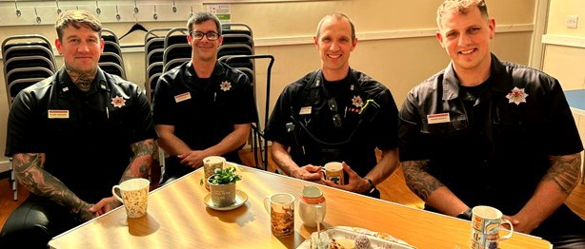
Easy to tell who was visiting on the 27th April there was a great big fire engine outside.
The whole crew were there ready to go into action if required at a moment’s notice. Stuart Urquhart the crew leader did most of the talking with Russell, George and David also contributing.

The Scottish Fire and Rescue Service
is committed to doing all it can to keep
you and your household safe from fire and other risks. They gave us lots of tips and good advice on how to prevent fires in the first place. They answered lots of questions and told us all about their training. It was a very informative afternoon and we all felt safer for it.

We will begin again on Monday August 24th.

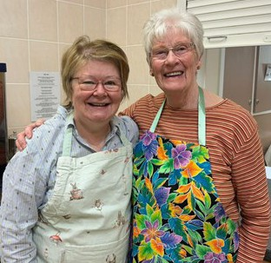
GUILD
Our March meeting was on Colours in the Bible. Brenda conducted the meeting.
Hazel had everyone sharing stories about their favourite colour and as to why that was the case.
Then using Church of Scotland material we discovered what all the colours represented in the bible and the specific readings to go with that. Brenda and Sylvia helped.
Then we made paper chains using all these colours. It was a surprisingly pleasant and therapeutic activity enjoyed by all . Followed by a cup of tea and a blether.
April was a fun afternoon on the theme of Build a House. Brenda conducted the meeting. Hazel organised a Build a House Drive along the lines of a Beetle Drive. Great concentration as everyone tried as fast as they could to throw a six to start. After 6 games Isobel Stewart was our winner.
This was followed by a quiz - all answers that you would find in your home, and of course a
cup of tea and a blether to finish.
On 28th April we had our Fundraising Buttery Morning in aid of the Guild Projects. There was a very good turnout and we raised the gratifying sum of £610.00.
We apologise to those of you who came along on 28th March expecting their tea and buttery, as the date had to be changed after the magazine had gone to be printed.
The ladies ready to start serving their customers

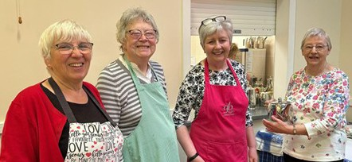
13

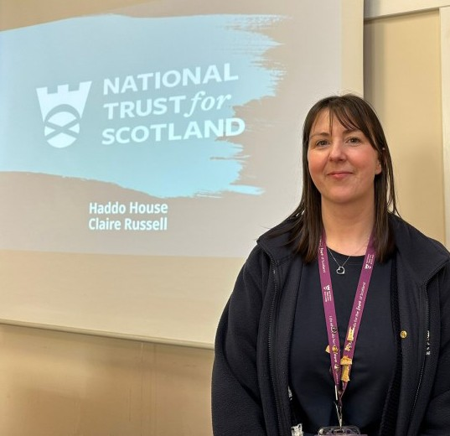
On 2nd March Claire Russell who is in charge of “ Visitor Experience” in Haddo House came to give us a quick history of Haddo. It was Designed in 1732 by William Adam, for the 2nd Earl of Aberdeen. But it was the 4th Earl of Aberdeen, George Hamilton Gordon (1784-1860) who invested in Haddo, planting 14 million trees, accumulating lots of the surrounding land and forming 3 manmade lakes. He was the Prime Minister who took us into the Crimea War.
SENIOR LADIES
Later John Campbell Gordon(1847-1934) 3rd son of the 5th Earl brought his young 3rd wife, Ishbel ( his first 2 wives having died
giving birth) to Haddo and she hated it. So he gave her £100,000, the equivalent of
£15,000,000 in today’s money, to improve the inside of the House. They added the beautiful chapel in the late 1880’s.
Ishbel was an amazing lady, devoting much of her time to being a suffragist and activist on behalf of women and servants . She was very much respected in Canada and where ever she lived for the work she did. At Haddo she was the founder and president of the Young Women’s Improvement Association.
During WW II Haddo House became a maternity hospital where 12,000 babies were born. David and June Gordon did a great deal for Haddo in the Arts World bringing lots of famous musicians and actors to the North East to join in the Haddo productions. It was they who gave Haddo House to the National Trust.
She finished her fascinating talk with a ghost story. No need to worry he is friendly.

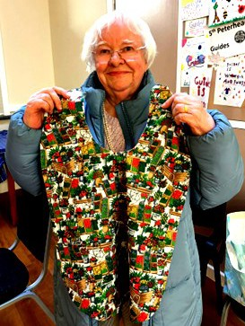
On March 16th Margaret Gifford came to tell us of her support for an orphanage in Malaysia.
She and her husband were often visitors to that country and were deeply affected by the plight of the orphans. They became friends with an Indian Christian lady called Josephine who ran an orphanage for abused orphans. These children could not get an education unless they had school uniform.
Margaret who has very creative hands started making lots of beautifully sewn items to sell to raise money for the orphanage. Over the past 13 years she has raised thousands of pounds for The Shaman Children’s Home. Rotary also contributed shelves, chairs and tables so they had a
DUNCAN ROSS
Monumental Sculptor Ltd Peterhead
Quality Handcrafted Granite Memorials
Additional inscriptions and renovations undertaken. Large selection of memorials on display.
Call 01779 479393 or
Visit Grange Road, Peterhead
5

We offer the complete range of legal and property services




Your local office is:
35 Queen Street, Peterhead, AB42 1TP ( (01779) 476351

www.stewartwatson.co.uk

proper eating area.
She had lots of photographs of the home and the children. She brought along a big bag of samples of her work which were quickly bought as they were so beautiful.
Margaret was an example of how one person can make such a big difference for good.

On the 30th March we had an old friend Tom Buchan who come to share his faith and his humour in the form of poetry. These poems which he has written over the years come he told us in 3 categories, some silly, some ridiculous and some to give you food for thought. He started with “The Air Show”. and finished with “ What do you think about Easter”.
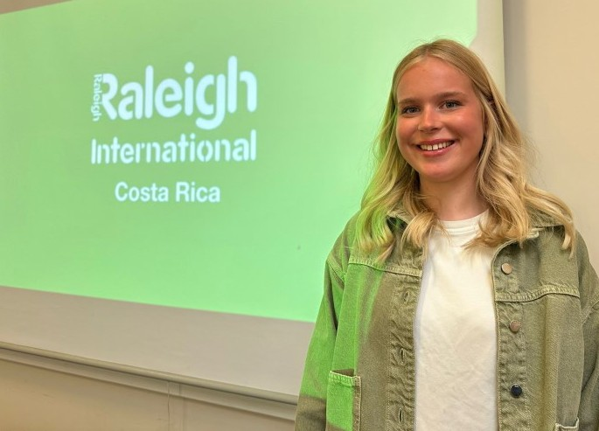
There was much laughter at the silly ones and much appreciation of the sincere, heartfelt ones about his faith.
Claudia Reynolds was our guest speaker on April 13th. The 17 year old had been a volunteer with Raleigh International in Costa Rica for 3 months as part of a gap year. There she took part in a conservation project learning all about the importance of diversity and how to use organic farming to help the local village which they did in practical ways.
They also spent 3 weeks trekking across the country from one coast to the other covering over 8 miles a day.

12

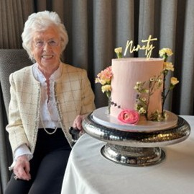
From Thursday 19th February, Lent Studies based on Corrie Ten Boom’s book of devotions for refuge and strength, “God is my Hiding Place”, took place every week untill Thursday 26th March in various churches in the town. The first one was in our Church hall when a film about Corrie Ten Boom was shown. The Maundy Thursday service was in our Church with some of our members and some from St Andrews taking part. The Good Friday service was then held in St Andrews Church.
CONGRATULATIONS to Elsa Baird who reached her 90th birthday in March.
“Elaine and I received a very warm welcome when we joined the congregation at New Parish Church after the closing of Peterhead Old Parish Church.
I attended Prince Street Hall Sunday School from an early age and John and I attended the Bible Class as teenagers. After John’s National Service and my Nurses’ Training, we married in 1962. Our daughter Jane was born in 1969 and our son Jon was born in 1972.
As a Christian, I look back on a happy life. Ups and downs – but that is life.”
We wish Elsa many more years of happy life with her family and as part of our congregation.
Setting up the prize table At one of the craft tables
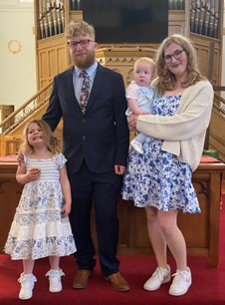
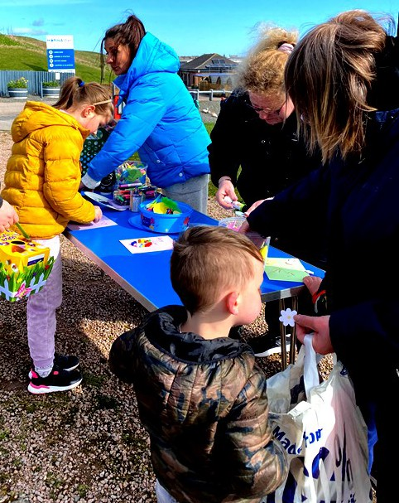
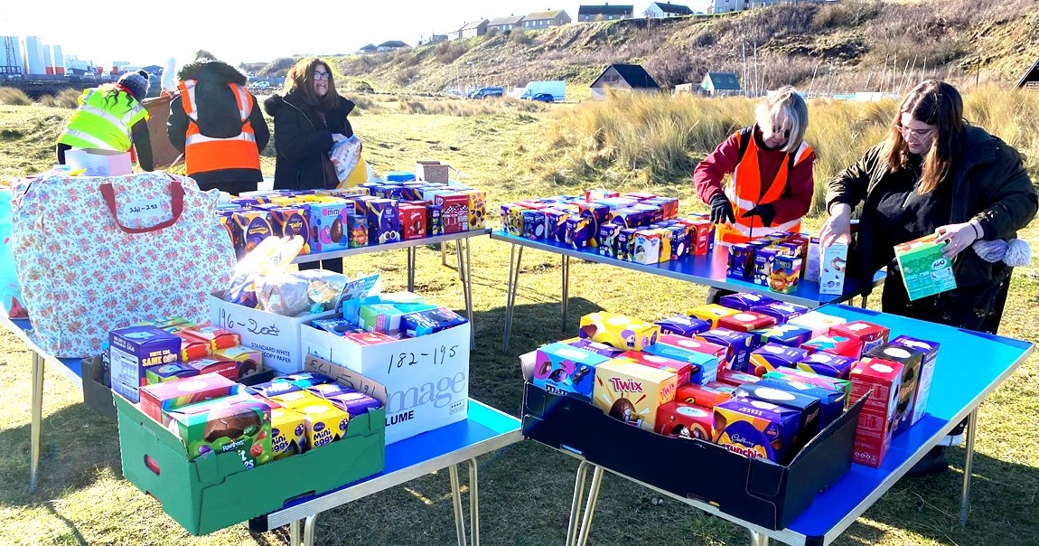
On Saturday 4th April we had our now annual Egg Hunt at the Lido. Once again mem- bers of our Church and St Andrews Church came up trumps and provid- ed enough sweets, chocolate eggs and
other small gifts to ensure that all 211 children who turned up could collect their 5 filled plastic eggs and also get a prize from the table. There were also tables full of crafts for the children to do before and after their Egg Hunt.
CHOIR NEWS
Since the last issue of the Church magazine the choir have continued with their rehearsals. At these we go through the hymns for the following Sunday and an introit and Anthem. We also rehearse introits and Anthems several weeks ahead to enable us to sing them well. New pieces are also learned, and some we have sung in the past but haven’t used for a while. Some of the more modern hymns/songs can be a bit challenging as they are often written off-beat and include a range of chords which, on occasion, are a bit off putting. Recently the children have been singing with the choir and also on their own. There are plans for them to sing more frequently. They have been rehearsing several new (to them) pieces and we are looking forward to hearing them sing them during the services. It is really uplifting hearing them singing with great enthusiasm. Thanks to the parents who bring the children to the rehearsals and wait patiently for them. It is really appreciated.

The choir have again been supporting Matumaini School of Hope in Tanzania, which is run by the Salvation Army. We have been supporting this for many years and are glad to be of help. Recently we, along with others, have been collecting drinking bottles with lids for the 250 children at the school. To date we have donated 71, and with the other donations the total has been surpassed. These and other items will be on their way in a few weeks time and we are certain the children will appreciate them when they arrive.

Sadly, this year we have lost one of our long-standing members. Anna Florence was in the choir for over fifty years, a lifetime of service. She was the choir treasurer and helped organise some of our events. She is greatly missed.

Please come along to one of our rehearsals and see and hear the choir sing through the pieces chosen for that week’s rehearsal. You might enjoy the occasion and want to come back again. We would welcome anyone who would like to join us in the choir and don’t forget the tea/coffee and biscuits afterwards.

During the service on Easter Sunday, we celebrated the baptisms of Keiron Warzala and his children, Bella and Dakota and welcomed Keiron and his partner Katie Findlay into membership of the Church. Bella already enjoys coming to Children’s Church on a Sunday and the congregation love to see Dakota with his mum and dad in the pew.

Forthcoming events

Sunday 7th June After the service there will be a light lunch in the hall followed by the Church A.G.M.
Saturday 13th June Mad Hatter’s Tea Party and Silent Auction in aid of Church refurbishment. Please enter by the main Church door and feel free to wear a hat.
Sunday14th June Sundays Together Family Fun Afternoon when the children will be having some building fun as well as helping to make decorations for the Holiday Club in July.
Sunday 28th June Celebration of Communion at 10.30am
6th to 10th July Mega Makers—Holiday Club including lunch, for children in primaries 1 – 7 in the school year coming to an end. From 9.45 am to 1pm
Saturday 18 th July Church open for refreshments after Scottish Week Parade Sunday 19th July Scottish Week Opening Worship with local dignitaries present Tuesday 21st July Afternoon of Scottish Fun for the Children and Young People with

Be joyful in hope, patient in affliction, faithful in prayer. Romans 12:12
Line Dancing
Thursday 23rd July Antiques Valuation in the hall

6 11

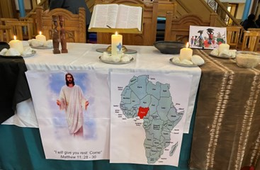
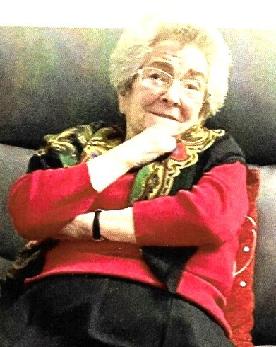On Friday 6th March at 2pm, Peterhead New Parish Church hosted Peterhead’s 2026 World Day of Prayer service. The service was prepared by the WDP committee of Nigeria and representatives of various churches in Peterhead took part. Adam and the choir led the singing and also sang a choir piece for us.
TRIBUTE TO ANNA FLORENCE

Anna Florence, a staunch member of Peterhead Old Parish Church and more recently, an active participant and Elder in Peterhead New Parish Church, was born and brought up locally, worked for the Coal Company in Seagate and then for Aberdeenshire Council. She was very dependable and accurate when balancing the books! Latterly, she enjoyed her job working at the local and general elections. She was a people’s person and this was evident when she welcomed Senior Ladies as they came into the hall on a Monday and also when we held the annual Coffee Mornings. She was treasurer for the Senior Ladies and also for the Choir, where she was a
member for many years. She was a keen member of a small group who conducted a short service at Kirkburn Court every fifth Friday afternoon and enjoyed compiling the six hymns that would be sung on each occasion.
She had special former work colleagues with whom she enjoyed socialising, with car runs out into the country, especially to ”The Lodge” at Strichen. Another great friend was Elsie Hay. They were always together.
Anna enjoyed following snooker, especially The Masters, and also TV dramas and Trilogies. She was always ready for a pick up on a Wednesday, going to the Congregational Church Café for lunch.
She was a regular user of the Dial-a-Bus, which took the ladies to Morrisons for their weekly shop on a Thursday.
Sadly Anna, who had led a very full life, passed into God’s presence suddenly and peacefully at the beginning of March. Her funeral took place on Friday 13th March with the Choir singing one of Anna’s favourites “To the river I am going”.
We will miss her! SM
CHURCH NEWS
There was a good turnout at the service and afterwards we enjoyed a lovely tea and fellowship in the hall;
On 15th March, Mothering Sunday, the congregation was greeted by bunches of flowers on pedestals, shelves and even the stairs, with even more in the sanctuary. At the end of the service, during which the children had handed out sweets, every woman present was invited to take a bunch of flowers home.
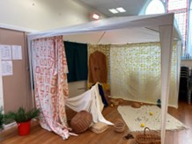
On Friday 27th March, Primary 6 and 7 children from Central school were invited over to our Church where we took them on an Easter Journey, led by Pamela Sloan of Scripture Union. The aim was to help the children understand what happened that first Easter. Taking part were several members of our congregation, appropriately dressed for the place and time period. We started out walking to Jerusalem, where we visited the
Temple where Jesus had turned out the traders. We lined the route where Jesus was expected to travel, waving palm branches and shouting “Hosannah”., but John came on telling us we had missed Jesus. He then led us to the Garden of Gethsemane, where we listened to the sound of Jesus being arrested by the Roman soldiers. The 32 children were then split into three groups where leaders encouraged them to
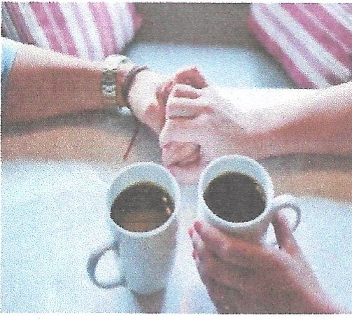discuss what they had heard. The groups were then asked to compete in a positive chant . But soon after it started the group leaders started to chant “Crucify, Crucify” and encouraged the children to change their chant to “Crucify” This demonstrated how many in the crowd in Jerusalem changed from welcoming Jesus to shouting for his death.
AGED PETERHEAD

Thistle Street, Peterhead (Town Centre) Telephone Number: 01779 472331
Opening Hours: Mon – Sat 10am – 12 Noon

We are a local volunteer network for North
Aberdeenshire.

We provide:
Sitting services.
Caravans for holiday (Fochabers) General information for the elderly.

If you have any spare time, even a couple of hours a week, and would be interested in becoming a sitter, which would include visiting houses, having a cuppa and a good old blether,
If you would like a getaway in one of the two caravans we have in Fochabers, one of which is equipped for the disabled and the other a bit more modern,
If you would like information about getting a sitter,
If you would like any general information for the elderly —

Please contact the number above or pop in and see us during opening times.
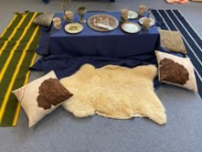
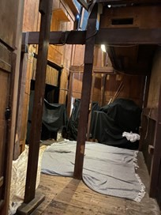
After this, the groups took turns to visit The Last Supper where they learned about Passover and Communion; the tomb, where they learned about Jesus Burial and resurrection, and the Craft table where they used templates and crayons to make white crosses on a coloured background.
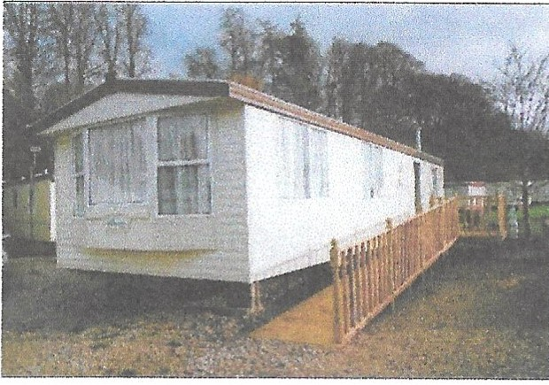
John then came running in, shouting “Jesus is alive” and gathered the children near the Garden (in the sanctuary) where they viewed the tomb with the stone rolled away and listened to the story of the
resurrection. Then, while the children enjoyed a snack back in their groups, they discussed their favourite parts of the morning, what they had learned that they did not know before and then wrote on paper crosses what they considered the most important thing they had learned. The crosses were then stuck on a wooden cross in the sanctuary.
Bibles were available for any of the children who wanted to take one to keep. The children
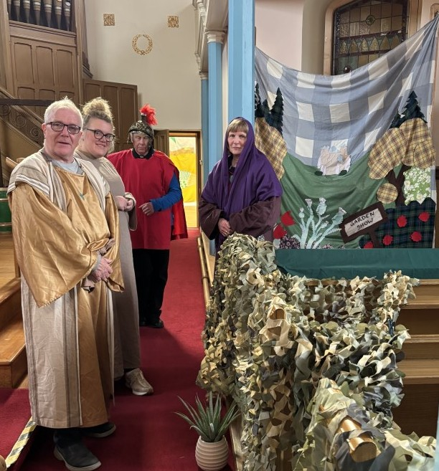
were really attentive and some of them already had a good grasp of what happened at Easter.

On Palm Sunday afternoon, at our Sunday Afternoon Together, we took the children and their parents on a slightly modified version of the Easter Journey, taking into account the younger ages of the children.

John, a Roman soldier and two of the group leaders beside our Garden of Gethsemane.

10 7



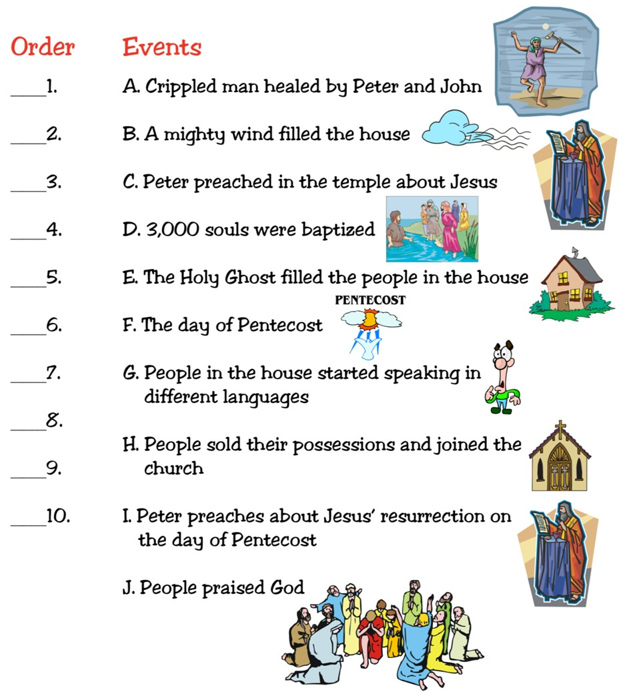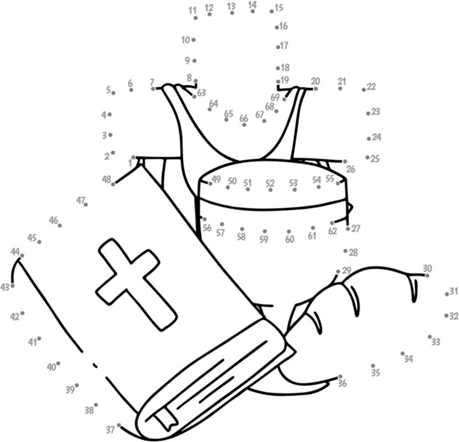Put these events in order. You will find them in Acts 2 and 3
CHILDREN’S CORNER

GIRLS’ BRIGADE
We completed all the divisional competition challenges. The topics were: ‘Turn back time’,
‘Messy v Noisy’, ‘Buzz for GB’, ‘It’s a wrap’, ‘Be kind’ and ‘Designer animals’.
We are delighted to say we won the Explorer section with “Be kind”. They visited our warm hub at Christmas, sung carols and handed out sweets they had made.
Leaders won their section with Messy v Noisy.
We made a lot of noise and mess one Monday
night!!
The Juniors did ‘It’s a wrap’, wrapping
Blythswood boxes for Christmas.
Brigaders did “Designer Animals”. They created a new animal from

parts from other animals. The whole company ‘Turned back time’, dressing in old uniform and doing a drama about the GB history.
We also all did ‘Buzz for GB’– singing ‘the bees go buzzing’. We won the overall competition with our entry.
The Explorers have finished their theme of ‘Travel Explorer’. The girls have been exploring transport and travelling around the world. The girls did drawings and colouring, crafts and played games, all related to their ‘travel’ theme.
Juniors and Brigaders topics were:-
Spiritual – Pray with Purpose/Prayer, Psalms, promise - They studied the Lord’s prayer and spoke about why and how we pray.
Educational – History of Girls’ Brigade and Computer Safety – The girls learned about the GB history and about how internet safety applies in different countries.
Physical – Circuit Games/Stations –including hurdles, throwing skills and running.
Service – Helping Others/Digital Safety – including filling 19 Blythswood boxes as part of the divisional challenge. Also the safety aspect of the internet.
All the Girls received their badges from our Commissioner Jenni Paton who was our special guest at our open night. The Explorer award was awarded to Emunah Tuwi. The Junior award went to Taylor Brown and Zoie Thain. The Brigader award went to Nika
Taranda. All girls had regular attendance and are very helpful and eager to participate in everything.
The Brigade cup this year has gone to two Leaders. These ladies had decided to continue their Girls’ Brigade training journey. They have completed their Gold Leadership training in only 7 months. They attended
zoom training sessions, did projects with other GB trainees and delivered physical and educational subjects to the girls as part of this years’ badgework. The cup went to Anna Pizzuto -Pomaco and Megan Mckay.
We are going to the Lido on the 8th June, where we will have a McDonald’s and have fun. Our new session will resume on Monday 24th August.

